GEORGE ALAPPATT
ORIGINAL DATASET SOURCE
https://www.kaggle.com/datasets/ahmedmohamed2003/retail-store-sales-dirty-for-data-cleaning?hl=en-IN
Introduction
For this project, I have selected a retail-store-sales data to understand how Excel and Power BI can be used for data analysis which allows me to practise data cleaning, analysis, and visualisation.
Objective
The main objective of this project is to clean and analyse employee data using Excel and Power BI.
IMPORT FILE Open excel and select “Get Data”Select “From File” Select “From .CSV File. Then select our csv file.

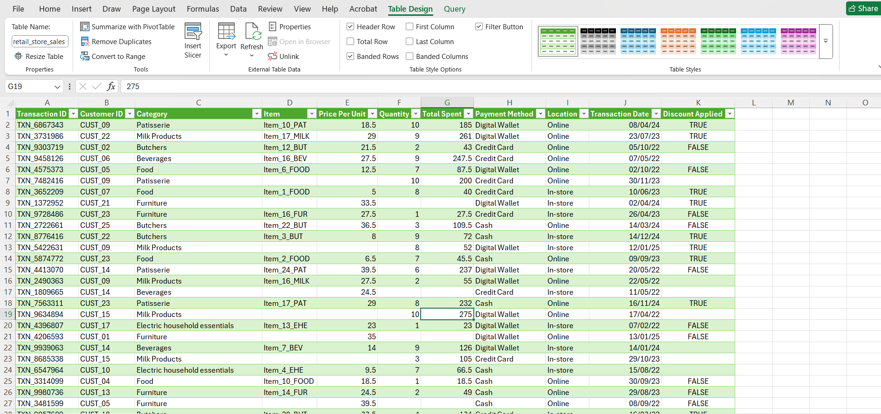

REPLACING MISSING VALUES Check the columns for blank cell. By using the option “Find & Select” “Go to Special Select the “Blanks” option. Here in the Discount Applied column and Item columns, the blank cells is replaced by “Unknown”.
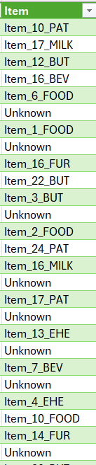
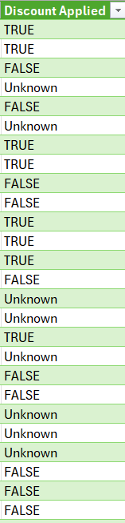

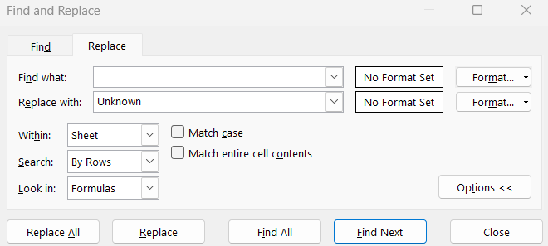

There is also missing values in “Total Spent”, Quantity and “Per Unit” columns. So I created new columns for modify these columns. Total spent is modified by Quantity*Per Unit. Quantity is modified by Total spent/per unit. Per Unit is modified by Total Spent/Quantity.
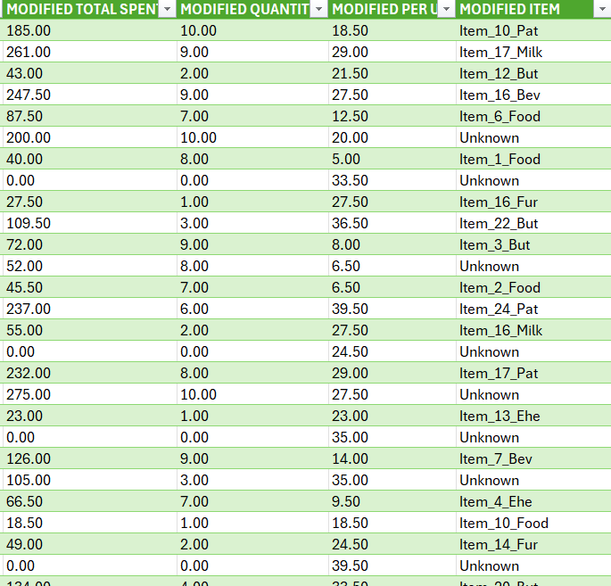
COLUMNS FORMATTING Select Transaction Date column change into date type in “home”. Item columns is modified by the function “=PROPER(TRIM([@Item]))” to change into same format. Modified total spent, quantity, per unit is changed into “Number” format.
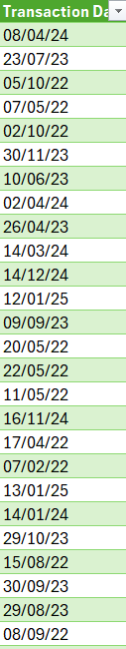

Remove Exact Duplicate Rows Select your entire data tableGo to the “Data” tab on the ribbonClick “Remove Duplicates”. There are 0 completely identical rows across the entire dataset. Every single Transaction ID is unique, meaning there are no repeated transaction entries.
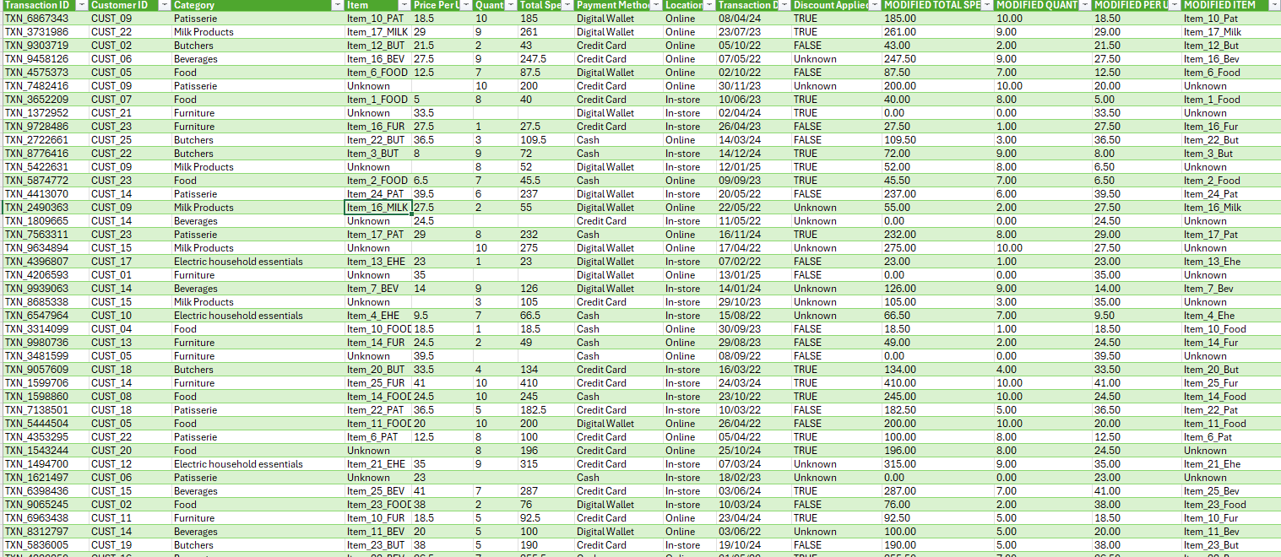
Conditional Formatting
Select the total spent column and select the conditional formatting option in home and select the “Data Bar” option.So we can see The length of each bar scales automatically based on the value in that specific cell relative to the minimum and maximum values in your dataset.
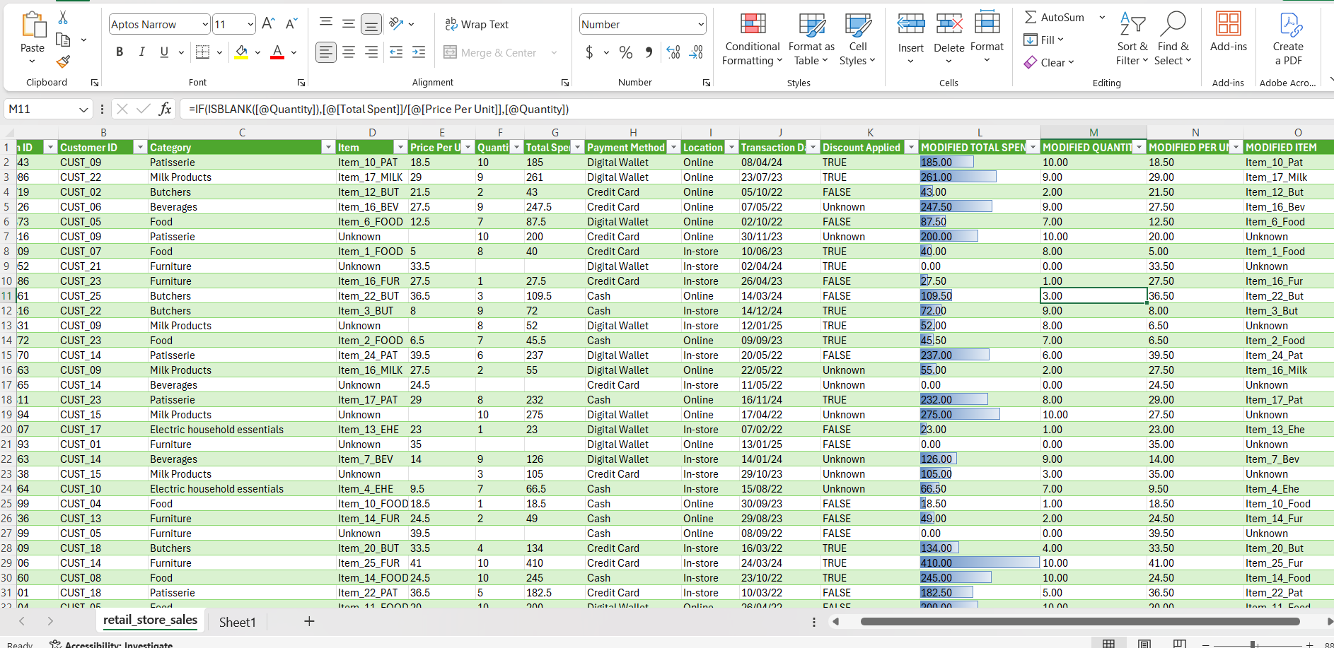

PIVOT TABLES
Created 3 pivot tables,one showing the categOry total values and one showing payment method total another showing the location -total value.
